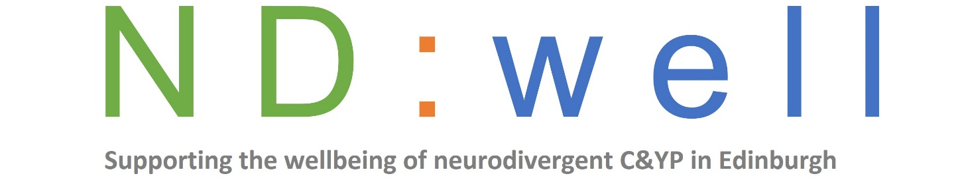
Referral form
Our services are for children and young people aged between 5 and 24 years old, living in Edinburgh who are neurodivergent, including diagnoses of autism, ADHD and intellectual disability.
We accept referrals directly from children and young people, their parents or professionals.
Please complete this form to refer yourself or a child or young person to our project. With any queries, please contact us at NDwell@barnardos.org.uk
About the child or young person
Name
Address inc. postcode
Contact number
Email
Date of birth
School (if applicable)
Named person (if applicable)
Diagnosis

About the parent/carer (if applicable)
Name
Address
Contact number
Email
Relationship to child/YP

About the referrer if a professional (if applicable)
Name of referrer
Job title
Organisation/service
Address
Phone
Email
Is the C/YP or their parent aware you are making the referral?

About key professionals involved (for example SLT, OT, Ed Psych, Social worker, CAMHS)
Name | Role | Contact details

Please describe below why you’re making this referral

Please indicate which of these areas you or the child/young person you’re referring would like support with?

Y/N | Y/N | Y/N | Y/N | Y/N | Y/N | Y/N

Please email your completed form to NDwell@barnardos.org.uk
We will be in touch to confirm receipt of the referral so please contact us if you don’t hear from us.

-------------------------------------------------------------------------------------------
For office use only
Date referral received
Data capture completed

Outcome of referral
Service(s) referred to:

Did not progress

