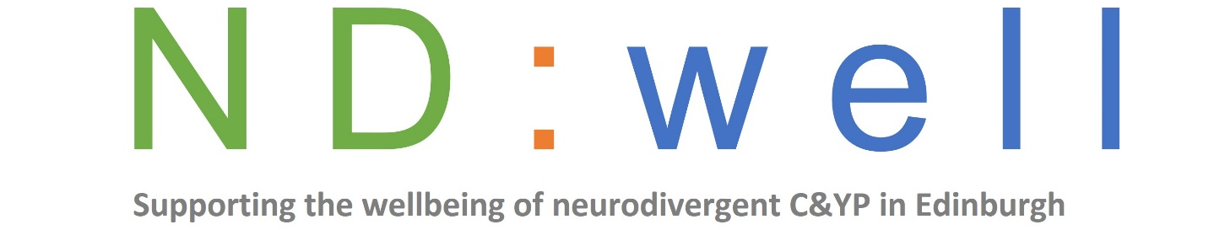
Referral form for ND:well Parent/Carer
info sessions with Tailor Ed
These online sessions are for parents and carers of autistic children and young people.
We accept referrals directly from parents and carers or professionals.
Please complete this form and return it to us at NDwell@tailoredfoundation.co.uk
About you and your child
Your name
Address inc. postcode
Contact number
Email
Childs name
Childs date of birth
School (if applicable)
Diagnosis

About the referrer if a professional (if applicable)
Name of referrer
Job title
Organisation/service
Address
Phone
Email
Is the parent aware you are making the referral?

Which topics are you interested in?
Y/N Emotion Regulation; understanding needs and developing tools (4 sessions)
Y/N Sharing an autism diagnosis with your child (2 sessions)
Y/N About energy management; helping young autistic people avoid and manage burnout (2 sessions)
Y/N Sleep (2 sessions)
Other (please specify): _________________________________________

Please email your completed form to NDwell@tailoredfoundation.co.uk
We will be in touch to confirm receipt and provide you with the Zoom link and dates of next sessions. Please contact us if you don’t hear from us.
-------------------------------------------------------------------------------------------
For office use only
Date referral received
Data capture completed

Outcome of referral
Service(s) offered

Did not progress

