
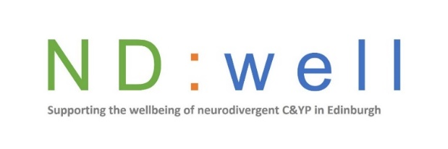
Referral Criteria for ND:Well/EDAN ND Wellbeing Groups

Tailor Ed delivers group support to neurodivergent children and young people, aged 5-18, living in Edinburgh. We operate a child centred, affirming, strength and rights based approach, using strategies, resources and tools matched to the needs of each child or young person attending. We offer individual sessions as follow up to groupwork to allow for individual reflection and personalized support.
We offer TWO options for groupwork through our two collaborations:
- ND:Well groups are for those with a confirmed Autism diagnosis.
- EDAN Hub groups for those with a confirmed diagnosis of ANY neurodivergence and/or those on the CAMHS neurodivergent assessment pathway for any type of neurodivergence.
(Please note: Wellbeing groupwork is a separate and different service from Tailor Ed’s traditional skills based services.)
Areas we can support:
- Interests, motivations and values | - Understanding medical and physical health needs
- Understanding and meeting sensory needs | - Self-awareness and self-advocacy
- Emotional awareness and regulation skills | - Anxiety
- Energy management, movement and nutrition | - Neurodivergent Identity
- Sleep | - Community and support networks

Our groups are delivered in the community, usually at No. 6 (Autism Initiatives building, 24 Hill Street).
Criteria:
- Edinburgh resident
- Age 5-16 for autism specific group and 5-18 for wider ND groups
- On ND Assessment pathway with CAMHS or a ND diagnosis (CYP must be aware of this)
- Attending school or community supports (this can include part time timetables, flexi schooling and alternative education providers e.g. forest schools or home-school tutor or activity and youth groups)
- Wellbeing Need (e.g. emotional regulation, risk taking behaviours, navigating friendships or a general interest in their own wellbeing). Not an acute, unmet or complex mental health need. Not a “life skill” need.
- Child or Young Person is aware of and consented to referral/participation
- Independent language/communication use (e.g. communicate views/questions/ask for support within an inclusive, supportive environment using speech, AAC or other means)
NB: We are unlikely to accept referrals for those who are unable to leave home, who require an adult to communicate on their behalf or who have an UNMET and/or active complex mental health need (e.g. eating disorder, active intentional physical self harm or active suicide attempts).

